KEMENTERIAN AGAMA
UNIVERSITAS ISLAM NEGERI MAULANA MALIK IBRAHIM MALANG
Jl. Gajayana No. 50 Malang 65144, Telp. (0341) 551354, Fax. (0341) 572533
Website : www.uin-malang.ac.id E-mail : info@uin-malang.ac.id
Nomor : Un.03/KS.01.7/3864/2016 10 Oktober 2016
Lampiran : 1 (satu) bendel
Perihal : Permintaan Informasi Harga Barang

Kepada Yth.
............................................................................................
di
‘- T e m p a t –

Dengan hormat,
Sehubungan rencana realisasi pelaksanaan pekerjaan Pengadaan Sarana Prasarana Berupa Alat Musik beserta Pendukungnya Unit Kegiatan Mahasiswa di Biro Akademik Kemahasiswaan dan Kerjasama (BAAKK) Tahun Anggaran 2016, bersama ini kami bermaksud agar perusahaan saudara memberikan informasi tentang harga barang sesuai dengan Rencana Anggaran Biaya (RAB) yang kami lampirkan dalam surat ini untuk data dukung survey pembuatan HPS (Harga Perkiraan Sendiri) Lelang Pengadaan Sarana Prasarana Berupa Alat Musik beserta Pendukungnya.
Apabila informasi harga yang saudara berikan sesuai dan kami nilai wajar, maka kami akan memberi kesempatan perusahaan saudara untuk membuat penawaran terhadap pekerjaaan tersebut.
Kami harap data barang dapat kami terima paling lambat pada :
Hari : Jum’at
Tanggal : 14 Oktober 2016
Tempat : Unit Layanan Pengadaan
Lantai II Gedung Rektorat UIN Maulana Malik Ibrahim Malang
Jl. Gajayana No. 50 Malang (0341) 570886

Adapun informasi harga tersebut bisa dikirim ke kantor ULP, di fax di no (0341) 570886 dan via e-mail ke : ulp@uin-malang.ac.id atau ulp_uinmalang@kemenag.go.id.
Demikian atas perhatian dan kerjasamanya yang baik, kami sampaikan terima kasih.

Pejabat Pembuat Komitmen,

Drs. H. A. Heru Achadi Hari, M.Si
NIP. 19690526 200003 1 003

Lampiran : Surat Permintaan Informasi Harga Barang
Nomor : Un.03/KS.01.7/3864/2016
Tanggal : 10 Oktober 2016

Rincian Anggaran Biaya (RAB)

Pekerjaan : Pengadaan Sarana Prasarana Berupa Alat Musik beserta Pendukungnya Unit Kegiatan Mahasiswa
Lokasi : Biro Akademik Kemahasiswaan dan Kerjasama (BAAKK)
Tahun Anggaran : 2016

No | Nama Barang | Spesifikasi | Gambar | Volume |  | Harga Satuan (Rp) | Jumlah (Rp)
A | Paduan Suara
1 | Keyboard | Setara Roland Keyboard BK-3  • Portable, self-contained keyboard with built-in sound system  • High-quality sounds, rhythms, and Music Assistants  • Comfortable, intuitive user interface  • Compatible with music rhythms from Roland’s BK, E, G, and VA series  • Play a variety of backing formats (SMF, MP3, WAV, and rhythms) and record performances with optional USB memory  • Roland Wireless Connect capability for cable-free communication with iPhone and iPad; free iOS apps available for music sharing, lyrics display, and more | 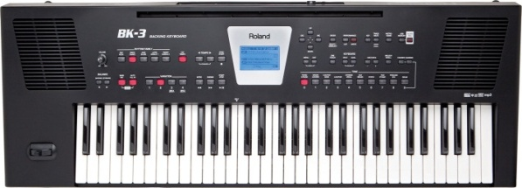 | 1 | Unit | ……....... | …….......
2 | Keyboard Amplifier | Setara ROLAND Keyboard Amplifier [KC-150]  • Output Power 65 Watt  • 12" Speaker and Piezo Tweeter  • 2-band EQ  • Input AUX  • XLR Mic | 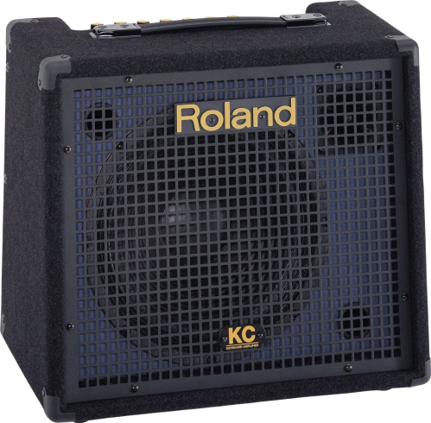 | 1 | Unit | ……....... | …….......
3 | Lampu Sorot LED Outdoor 10 Watt COLOUR | Lampu Sorot 10watt 220volt RGB  - input voltage : 100-240V(AC)  - Power : 10W RGB  - Dilengkapi remote untuk mengganti warna cahaya  - Berat : 600 gr | 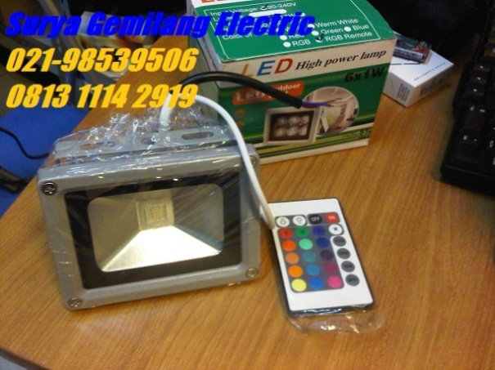 | 2 | Unit | ……....... | …….......
4 | Sustain | Type : ROLAND Damper Pedal [DP-10]  • Keyboard Pedal, Standard Pedal Switch  • High-quality pedal with non-slip rubber base  • Extra long cable for stacked keyboard setups  • Full and half-damper compatible | 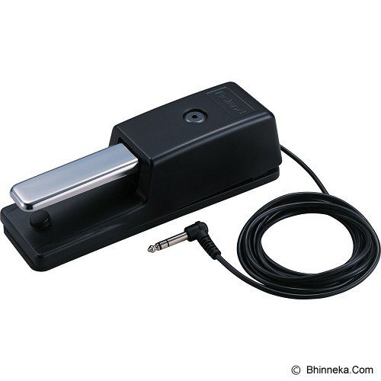 | 1 | Unit | ……....... | …….......
5 | Speaker Portable | - SAMSON Monitor Speaker Auro D12  • 2-way Passive Loudspeaker System  • 12" Speaker  • Power 400 Watt  • 1.34-inch (34mm) compression driver with 1-inch exit  - CHANNEL Speaker Stand [YM2010]  • Tinggi maks. 1,8m  • beban berat speaker hingga 68 kg  • Uk (L x W x H cm) 15 x 15 x 105  • Garansi Merchant | 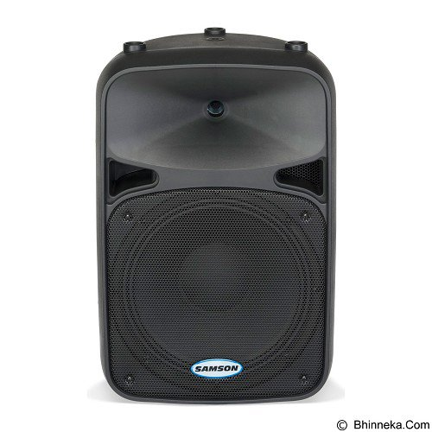 | 1 | Unit | ……....... | …….......
B | Simfoni
1 | Stand Mic | - Mic Boom arm Length : 1000mm/39.4”  - Adjustable height :190 mm(7.5”) to 960mm (37.8”)  - Base type :adjustable screw-on clamp or desktop placement  - Weight :1.41Kf/ 3.1Ibs (Including cable) | 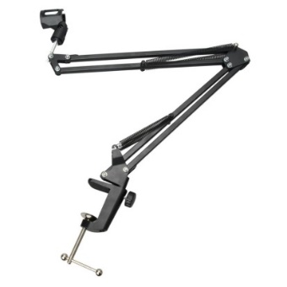 | 2 | Unit | ……....... | …….......
2 | Mic Siaran | - MULTI-PATTERN CONDENSOR MIC  - Switchable Supercardioid, Omni and Figure-8 pickup patterns  - Dual 19mm capsule design  - Switchable high-pass filter and 10dB pad  - Gold-plated XLR connectors  - Carry Case & swivel mount included  - Optional SP01 shockmount available | 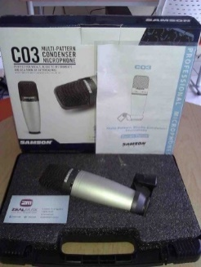 | 2 | Unit | ……....... | …….......
3 | Mixer Allen dan Health GL2400-16 | - inputs – MIC Preampers 16 x XLR  - inputes – line 24 x TRS  - output – main : 3 x XLR, 2 x TRS  - output – Direct :14 x TRS  - output – other : 2 x TRS (2-TRL) 4 xXLR (groups)  - heandphones: 1 x ¼”  - send/return 1/O :6 x TRS (sends | 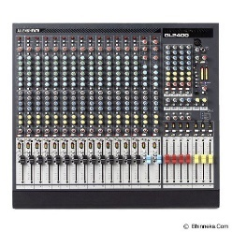 | 1 | Unit | ……....... | …….......
C | Lembaga Kajian, Penelitian dan Pengembangan Mahasiswa
1 | Pengadaan Microphone Wireless | - SAMSON Stage 55 Handheld System  - Microphone Live Wireless  - HT5 Dynamic Handheld Microphone Transmitter  - 1 Receiver SR55 | 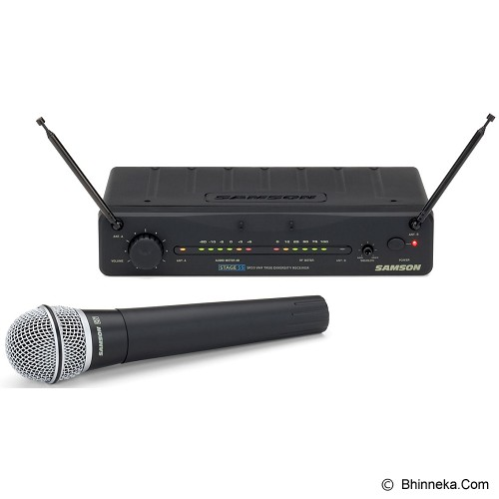 | 1 | Unit | ……....... | …….......
2 | Sound System | - PHILIPS Home Theater 5.1 inch  - 5.1 inch Home Theater Speaker System  - Dolby Digital Plus  - Double Bass Sound  - USB Playback  - Dolby TrueHD and DTS-HD  - Bluetooth and NFC  - HDMI 1080p | 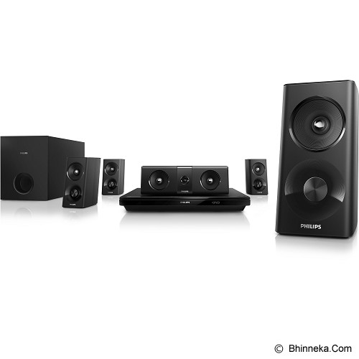 | 1 | Unit | ……....... | …….......
D | Pramuka
1 | Terbangan Rebbana Qasidah | - Alat music hadrah  - yang terkecil berukuran diameter 18 cm (ketipung/ kotek)  - 22 cm (B3/ tanggung/ keplak/ keprak),  - 26 cm, 27, cm, 28 cm (B2),  - 29, cm, 30 cm, 31, cm,32 cm (B1/ stelan kecil/ hadroh/ Bass 3)  - 35 cm, 36, cm dan terbesar Berukuran 37 cm (stelan besar/ diba/ terbang/ bass 1 & 2)  - bahan dari kayu asem  - kulit kambing | 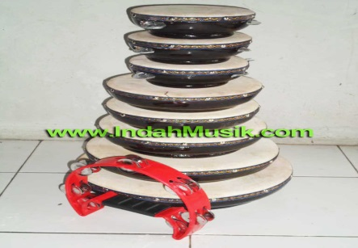 | 1 | Set | ……....... | …….......
2 | Micropone | - Setara Samson Stage 55 Handheld System  - ST5 beltpackpemancar  - LM10 lavaliermikrofon  - pickup pola Omnidirectional  - clip-on terpadudesain  - adaptor AC dan 1/4-inch termasukkabel  - AR55 Tahap 55 penerima | 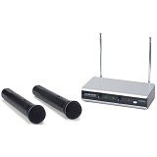 | 1 | Unit | ……....... | …….......
3 | Mixer Sound | - Setara ALTO Mixer Live  - Mixer Live, Audio 8 Channels, 4 Mic Input, 3-Band EQ, RCA, 16 Total Inputs, 2 Stereo Input Channels, AUX Inputs/Outputs, Switchable Phantom Power, Footswitch Input | 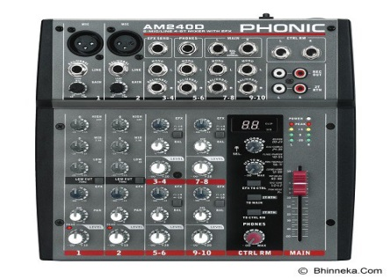 | 1 | Unit | ……....... | …….......
E | Teater Komedi Kontemporer
1 | Mic Wireless | - Pyle-Pro PDWM8900 Rack Mount 8 Channel Wireless Microphone System with 8 Lavalier/Headsets  - Professional VHF 8 Channel Wireless Microphone System –¼’’ Individual Line Outputs and Mixed ¼’’ Outputs – Operation Range: 150 – 600 ft.  - Dual Telescoping Receiver Antennas – Available Frequencies (Hz): Set 1 – 215.5, 174.8, 200.6, 180.8/Set 2 – 212.6, 190.1, 214.2, 193.0 – Signal to Noise Ratio: 90 dB  - 8 Volume Controls – One For Each Channel – Dynamic Range: 92dB - Dimensions Without Rack Mount: 1.8’’ x 16.5’’ x 8.7’’  - Includes 4 LavalierMics and 4 Headset Mics– Total Harmonic Distortion: 0.5% - Receiver Dimensions With Rack Mount: 1.8’’ x 18.9’’ x 8.7’’  - 8 Belt Packs On/Off Broadcasting Switch – Frequency Response: 50 Hz – 16 kHz  - Professional VHF 8 Channel Wireless Microphone System –¼’’ Individual Line Outputs and Mixed ¼’’ Outputs – Operation  - Range: 150 – 600 ft.  - Dual Telescoping Receiver Antennas – Available Frequencies (Hz): Set 1 – 215.5, 174.8, 200.6, 180.8/Set 2 – | 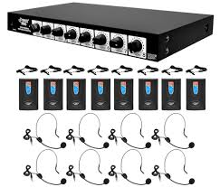 | 3 | Unit | ……....... | …….......
2 | Violin | - Paesold Violin Outfit PA802 size 4/4  - Top: Alpine Spruce  - Back,sides,neck: European Maple  - Fingerboard, nuts: Ebony  - Wood quality: A+  - Hand varnish: spirit varnish  - Antique varnish: Yes  - Tailpiece: Wittner Ultra  - Pegs: Ebony Standard  - Strings: Thomasik  - Hancrafted in Germany | 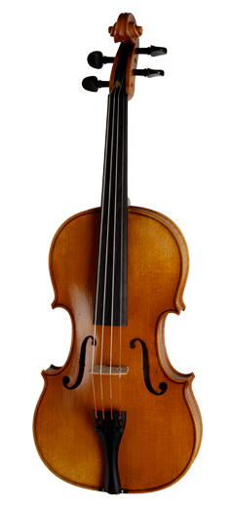 | 1 | Unit | ……....... | …….......
3 | Bongo dan conga | - Bongo dan conga LP Aspire 10” & 11” Natural Wood Conga Set & Bongos  - Congas are 28" tall, crafted from kiln dried, environmentally friendly Siam Oak  - Black, powder coated LP Aspire side plates  - 9⁄32" diameter tuning lug  - EZ Curve Rims which have improved strength, a unique skin wire channel, and a curved surface that provides great playing comfort  - Natural rawhide tucked heads  - Bongo Bracket Not Included, part number is LPA244S  - Tuning wrench included  - CP Traditional Bongos are constructed of kiln dried, environmentally friendly Siam Oak with 6" and 7" Natural Rawhide Heads and Cuban-Style steel bottoms. | 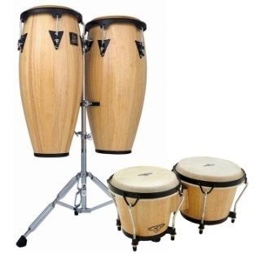 | 2 | Unit | ……....... | …….......
F | Komunitas Musik (Kommust)
 | RECORDING EQUIPMENT |  |  |  |  | ……....... | …….......
1 | Sound card | - Setara Tascam us1800 16 channel  - 16 simultaneous inputs  - 4 simultaneous outputs  - 14 analog inputs  (8x) XLR Mic  - inputs with phantom power  - (2x) 1/4" TRS LINE/GUITAR inputs on the front panel  - (4x) 1/4" TRS LINE inputs on the rear panel  - Stereo S/PDIF Digital  - Input/Output  - Zero-latency  - Hardware  - Monitoring  - Independent  - Monitor and Headphone  - Outputs  - Stereo monitor  - output (DAW return (stereo) and input (mono))  - 16-channel MIDI Input and Output  USB 2.0  - connection to Mac/Windows  Up to 96kHz/24-bit Audio Resolution  - Cubase LE 5 48-track workstation software included  ASIO and Core Audio support  Windows XP, Windows Vista, Windows 7 and Mac OS X compatible | 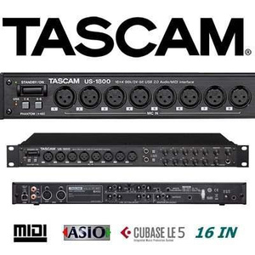 | 1 | Unit | ……....... | …….......
2 | Mic drum | Setara Samson 8 Kit Drum's Microphone Set  - 2 C01 Large Diaphragm Condensers for overheads  - 3 Q-toms for dynamic tom miking with integrated rim mount clip  - 1 Q-snare with integrated rim mount clip for precise snare drum miking  - 1 Q-kick perfect for capturing the low-end attack of bass drums  - 1 C02H Mini Pencil Condenser for hi-hat or ride cymbals  - All microphones feature Gold-plated XLR connections  - Complete kit comes packed in a rugged road case | 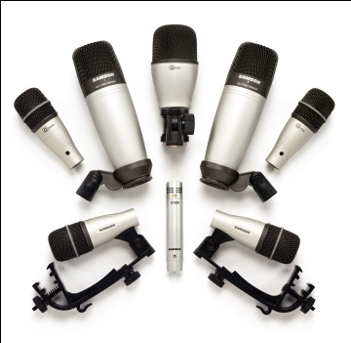 | 1 | Unit | ……....... | …….......
3 | Mic vokal recording | - ISK RM8 Mic, ShockMount, Hardcase, Wallet  - Pola Polar Switchable  - Low – cut Beralih  - 0dB , – 10dB Pad Beralih  - Emas Murni – Coated Grille Desain  - Pola Polar : Uni / Bi / Omni – directional  - Frequency Response : 20Hz – 20kHz  – Sensitivitas : – 36db ± 2dB ( 0dB = 1V/Pa pada 1kHz )  – Output Impedance : 150Ω ± 30 % ( pada 1kHz )  - Beban Impedansi : ≥ Ω  - Setara Tingkat Kebisingan : 15dB A0 | 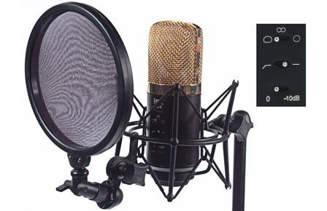 | 1 | Unit | ……....... | …….......
4 | Speaker recording | - Monitor Speaker System, 2-Way, 5" Cone Woofer, 1" Dome Tweeter, 54Hz - 30kHz Frequency, 45W Power Consumption | 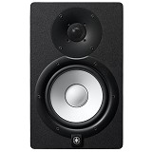 | 1 | Unit | ……....... | …….......
5 | Headphone | - Setara Marshall Major Mic (Pitch Black)  - Compatible with devices using 3.5mm plug | 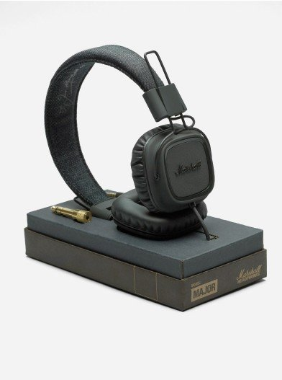 | 1 | Unit | ……....... | …….......
6 | Stand mic | - Setara Hercules MS201B Mic Stand | 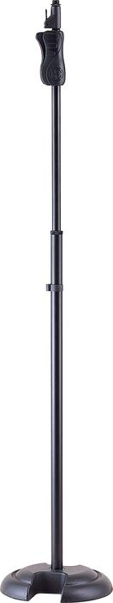 | 1 | Unit | ……....... | …….......
7 | Stand book | - Setara AXL ROSE SLK-340 I  - The Highest Quality In Book Stand, Black Colour With 2 Mic Holder | 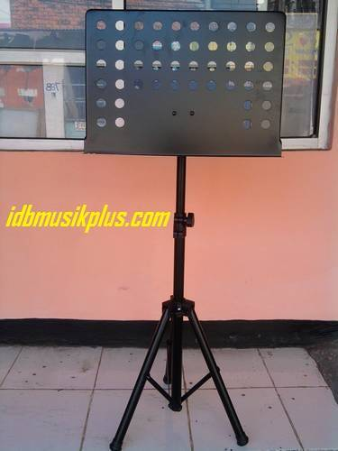 | 1 | Unit | ……....... | …….......
 | FASILITAS PENDUKUNG/ALAT BAND
1 | Pedal | - Setara Tama Iron Cobra |  | 1 | Set | ……....... | …….......
2 | Drum Throne / Kursi Drum | - Setara Mapex T755A Drum Throne |  | 1 | Set | ……....... | …….......
3 | Pickup Guitar | - Setara DiMarzio Virtual Hot PAF DP214 |  | 1 | Set | ……....... | …….......
4 | Cymbal | - AA medium crash 15"  - AA rock crash 17"  - XS20 hats 14"  - AAX Stage Ride 19"  - B8 chinesse 18"  - XS20 splash 10"  - 16" AAX Saturation Crash  - 18" HHX Studio Crash  - 21” HHX Raw Bell Dry Ride  - 11” AAX X-Plosion Splash  - 9" Sabian Vault Radia Nano Hats  - 18" Paiste Twenty Custom Thin China |  | 1 | Set | ……....... | …….......
5 | Drumhead/membran drum | - Evans B 14 HD Dry Snare  - Evans BD 24 GB3 - EQ3 Batter Clear Bass Drum  - Evans BD 22 R EMAD Bass Drum Reso  - Evans TT 12 G2 Tom  - Evans TT 13 G2 Tom 2  - Evans TT 18 G2 |  | 1 | Set | ……....... | …….......
6 | Gitar string/senar gitar | - Ernieball electric guitar string (0.10 – 0.46) 6 string (REGULAR SLINKY) (6 set)  - Ernieball (0.09 – 0.42) 6 String (RPS SUPER SLINKY) (6 set)  - Ernieball acoustic guitar string (0.10 - 0.50) 6 string (EXTRA SLINKY) (6 set)  - Ernieball electric bass string (0.45 – 100) 4 string (SUPER SLINKY) (6 set)  - Sumber: http://fjb.kaskus.co.id/product/000000000000000009061572/ernie-ball-senar-usa/1 |  | 1 | Set | ……....... | …….......
G | Pagar Nusa
1 | Kendang Pencak Silat | 1 set lengkap kendang pencak silat atau biasanya 1 set alat music bantengan  Terdiri dari berbagai alat music  - KendangJawaTimuran 2 (dua) buah (Kendang Lanang dan KendangWadhon)  - Ancak (Penyangga) kendang 2 (dua) buah  - 1 Pasang Kenong (1 Kethukdan 1 Kempyang) beserta dudukannya  - Pemukul Kenong  - GendangJidor/ (alternatifnya Bass Drum) 1 (satu) buah  - Tempat/ Penyangga Gendang Jidor  - Pemukul Jidor | 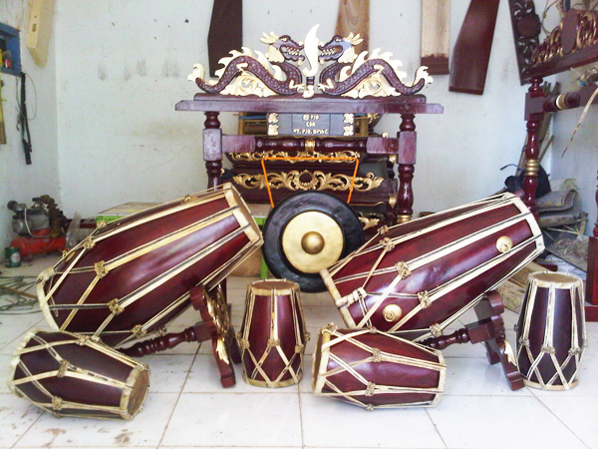 | 1 | Set | ……....... | …….......
H | Seni Religius
1 | Kyboard | - Setara ROLAND BK-5 OR (ORIENTAL)  - Continuing a long tradition of successful world-music products, Roland proudly announces the BK-5 OR, addressing the sounds of the Middle East as well as Turkey and North Africa. The BK-5 OR retains all characteristics and features of the recently announced BK-5 and adds newly created sounds and rhythms.Sounds and rhythms from the Middle East, Turkey, and North Africa12 scale-tuning buttons with dedicated scale memories. Instant playback of backing tracks directly from USB memory  - SUMBER: https://galerimusikindonesia.com/roland-bk-5-or-backing-keyboard-id | 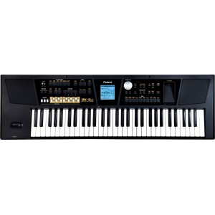 | 1 | Unit | ……....... | …….......
2 | Mixer | SOUNDCRAFT LIVE 8 32  Applications:  - 8-bus live mixing  - FOH mixing  - Touring bands  - Venues and theatres  - Installations  - Recording direct to multitrack  Main Features :  - 24, 32 and 40 channels frame sizes  - 8 group busses  - UltraMic+™ preamp with up to 66dB gain range  - +48V phantom power, individually switchable on each channel  - 4-band EQ with two swept mid bands  - 4 mute groups  - Additional outputs on 10 x 2 matrix  - Two stereo input channels  - 8 stereo returns  - Phase reverse on mono inputs  - 18dB/octave high-pass filter  - 6 aux sends, configurable to give up to 4 pre or post fade sends | 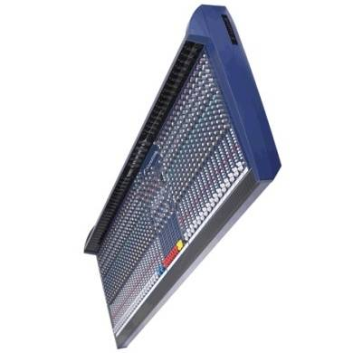 | 1 | Unit | ……....... | …….......
3 | Guitar Bass Elektronik | - BASS MB-200 SUNBURST  - Model MB200  - Ukuran (L x W x H cm) 20 x 5 x 100  - Berat (kg) 13 | 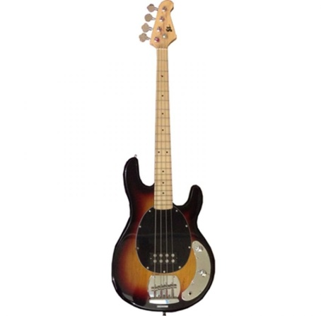 | 1 | Unit | ……....... | …….......
4 | Snake Cable | SNAKE CABLE AXL AUDION DRUM MODE 2485  Reliability and heavy duty multi pair link cable with aluminum  foil to reduce RF signal  Silvered cooper shield 20x 0.12 conduct wire with PE insulation  and PVC inner jacket. | 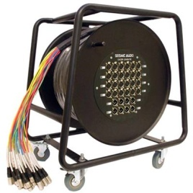 | 1 | Set | ……....... | …….......
5 | Mic Drum | AKG RYTHM PACK 6 Pc Of High Quality Microphone.  The Rhythm Pack professional drum microphone set contains everything you need to professionally pick up a complete drum set. More than this, the microphones can be used for miking percussion, bass and guitar amps, brass, woodwind and lots of other instruments. The included microphones represent a selection of valuable tools:  1 x D112 bass drum microphone  2 x C430 for overheads  3 x D40 for toms, snare and more  The D112 has earned a well-deserved reputation worldwide as the best kick drum microphone ever made. The versatility of the D40 will stand up to night-after-night onstage use. The C430 is compact with a uniquely crisp sound. This complete set comes in a protective aluminum carrying case. | 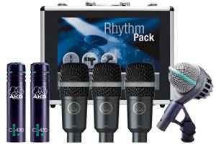 | 1 | Unit | ……....... | …….......
6 | Sub Woofer | SUBWOOFER PASIF PROFESSIONAL AUDERPRO AP-138SP, 18 INCH  - FrekuensiRespon + / -3dB : 34Hz ? 140Hz  - Sensitivitas 1 W @ 1 M : 99dB  - SPL Maksimum : 135 dB  - SistemImpedansi : 8 Ohm  - DayaMasukSuaraMaksimum : 2.000 Watt  - DayaMasukSuara Normal : 1.000 Watt  - RentangFrekuensi : ( -10 dB) 35Hz ? 120Hz  - SistemTipe Speaker : Subwoofer 18 Inch  - Bahan Finish : Plywood Hitam  - KonektorSaluranMasuk / Input : Speakon  - KonektorSaluranKeluar / Output : Speakon  - BeratBersih ( KG) : 50 Kg/ Unit  - BeratKotor ( KG) : 52 Kg/ Unit  - Dimensi :  - Tinggi : 820 MM  - Lebar : 600 MM  - Kedalaman / Kebelakang : 700 MM | 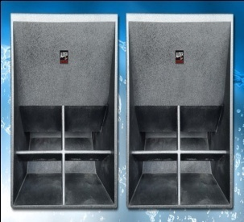 | 1 | Unit | ……....... | …….......
7 | Power Amplifier | POWER AMPLIFIER PROFESSIONAL AUDERPRO SA-900  TipeBarang : SA-900  Power Output / DayaKeluarSetiap Chanel/ SaluranPada :  … … … . 8 Ohm 1.000 Watt  … … … . 4 Ohm 1.800 Watt  … … … . 2 Ohm 3.200 Watt  … … … . Bridge 4.200 Watt  ResponFrekuensi ( + 0/ -0.3dB, 1w/ 8 Ohm) : 20Hz – 20kHz, -30dB@ 135kHz  Range Kekuatan ( Padadaya 4 Ohm) : -0, 23dB/ +  MaksimumTegangan Output / KeluaranPuncak : 142 Volt  MaksimumTegangan Output / KeluaranMurni : 100 Volt  THD + N ( Padadaya 4 Ohm/ 1kHz) : < 0.01%  SMPTE IMD ( Padadaya 8 Ohm, 60Hz & 7kHz : 60dB  Sensitivitas Input Standar ( PadaDaya 8 Ohm) # : 0.775V  Gain TeganganStandar ( Padadaya @ 8 Ohm) # : X110.5  Impedansi Input / SaluranMasuk ( Stereo/ Mono) : > 20K Ohm / > 10K Ohm  Hum dan Noise ( Padadayapenuh 4 Ohm) : -105dB  Crosstalk ( Padadayapenuh 4 Ohm) : > 60dB  DayaTegangan : AC 220V danfrekuensi 50/ 60Hz  Pendingin : Duakipaspendingindibagian panel belakang  LED Indikator ( Per chanel) : Signal, Clip/ Limit, Load/ Temp, Aktif  Dimensi ( Tinggi x Panjang x Lebar) dalam MM : 133 x 483 x 500 | 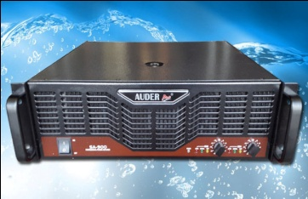 | 1 | Unit | ……....... | …….......
8 | Speaker Pasif | SPEAKER PASIF PROFESSIONAL AUDERPRO AP-235P, 2 X 15 INCH  - MODEL : AP-235P  - FrekuensiRespon + / -3dB : 36Hz ? 18kHz  - Sensitivitas 1 W @ 1 M : 99dB  - SPL Maksimum : 135 dB  - SistemImpedansi : 8 Ohm  - DayaMasukSuaraMaksimum : 1.800 Watt  - DayaMasukSuara Normal : 900 Watt  - RentangFrekuensi : ( -10 dB) 36Hz ? 20kHz  - SistemTipeSpeaker : 2 X 15 Inch, 2 ? Way  - BahanFinish : Plywood Hitam  - Lubang Stand Bawah : ? Tidak Ada?  - Lubang Stand Atas : ? Tidak Ada?  - LubangBautGantung : ? Tidak Ada?  - KonektorSaluranMasuk / Input : Speakon  - KonektorSaluranKeluar / Output : Speakon  - BeratBersih ( KG) : 40 Kg/ Unit  - BeratKotor ( KG) : 42 Kg/ Unit  - Dimensi :  - Tinggi : 1.200 MM  - Lebar : 500 MM  - Kedalaman / Kebelakang : 500 MM  - SUMBER:http://jualsoundsystem.com/produk/speaker-pasif-professional/ap-235p/ | 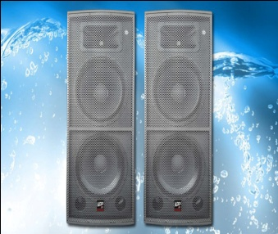 | 1 | Unit | ……....... | …….......
9 | Power Amplifier | POWER AMPLIFIER PROFESSIONAL AUDERPRO SA-700  Power output each Channel: 8 Ohm ........ 750 Watt  (1 kHz, 0.01% THD+N) 4 Ohm ........ 1400 Watt  2 Ohm ....... 2400 Watt  Bridged ..... 3000 Watt  Frequency Response (+0/-0,3dB, 1w/8 ohm: 20Hz-20Khz, -30dB@135kHz  Power Bandwidth (rated power at 4 ohm): 20Hz-20kHz, -0.23dB/+0.85dB  Max Peak Output Voltage: 128V  Max RMS Output Voltage (each chanel): 92V  THD+N (rated power, 4 ohm/1kHz): 20K ohm/>10K ohm  Hum and Noise ("A" weighted, full power at 4 ohm): -105dB  Crosstalk ("A", weighted, full power at 4 ohm): >-60dB  Input Connectors (Per channel): Female XLR (pin 2+, configurablefor pin  3+) TRS (tip+)  Power Supply (factory configured): 220V, 50/60Hz  Cooling: Two rear panel variable speed DC fans, filters detatchable without  tools  LED Indicators (per channel): Clip/Limit, Signal, Temp/DC, Active  Demensions (HxWxD): 133 x 483 x 400mm  Gross Weight: 32.68kg  Nes Weight: 30.42kg | 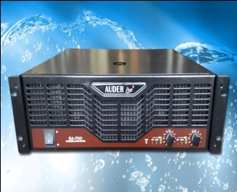 | 1 | Unit | ……....... | …….......
10 | Speaker Aktif | SPEAKER AKTIF PROFESSIONAL AUDERPRO AP115A, 15 INCH  - FrekuensiRespon + / -3dB : 38Hz ? 18kHz  - Sensitivitas 1 W @ 1 M : 99dB  - SPL Maksimum : 135 dB  - SistemImpedansi : 8 Ohm  - DayaKeluarSuaraMaksimum : 1.100 Watt  - DayaKeluarSuara Normal : 550 Watt  - Daya RMS : 275 Watt  - RentangFrekuensi : ( -10 dB) 39Hz ? 20kHz  - SistemTipeSpeaker : 15 Inch, 2 ? Way  - BahanFinish : Fiber Hitam  - Lubang Stand Bawah : ? Ada?  - Lubang Stand Atas : ? Tidak Ada?  - LubangBautGantung : ? Ada?  - KonektorSaluranMasuk / Line Input : XLR Jack  - Konektor Input Microphone : XLR & 1 1/ 43 Jack  - KonektorSaluranKeluar / Line Output : XLR Jack  - BeratBersih ( KG) : 25 Kg/ Unit  - BeratKotor ( KG) : 27 Kg/ Unit  - Dimensi :  - Tinggi : 700 MM  - Lebar : 470 MM  - Kedalaman / Kebelakang : 370 MM  - Daya : Tegangan 220~ 240V, 50 / 60Hz  - Indikator Posisi Nyala : Lampu Led | 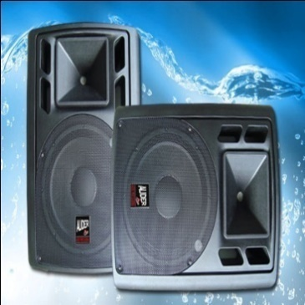 | 1 | Unit | ……....... | …….......
11 | Module Drum | Alesis DM5 Drum Module Brain Trigger Pad Controller  DM5 is a classic Alesis drum-sound module for drummers, programmers, producers, and anyone else who needs great-sounding drums and percussion. DM5 contains 540 stereo, 18-bit drum sounds that can be assigned to any of the 21 programmable drumsets. 12 trigger inputs enable DM5 to be used with all Alesis drum and cymbal pads, SURGE Cymbals, and the triggering devices from most other major manufacturers. | 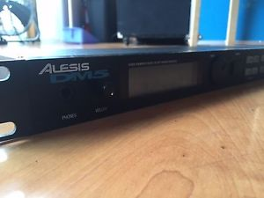  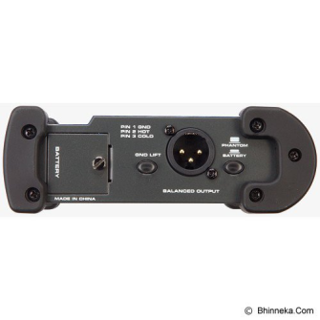 | 1 | Set | ……....... | …….......
12 | Direct Box | Setara SAMSON Mini Direct Box  - Perfect for stage and studio  - Switchable input level handles instrument and speaker levels  - 48 Volt phantom power or 9 volt operation with auto battery shut off  - Switchable ground lift  - 1/4" link output |  | 6 | Unit | ……....... | …….......
13 | Guitar Effects | Model ZOOM Guitar Multi-Effects [G3X]  - Guitar Multi-Effects, Effect Types 116, Patch Memory 10 Patches x 10 Banks, LCD x 3 Display, Control Input FP02 / FS01, Pedal | 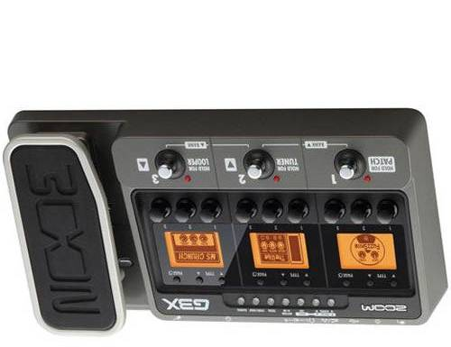 | 1 | Unit | ……....... | …….......
Jumlah |  |  |  |  |  |  | …….......
Terbilang :

NB :
* Harga sudah termasuk pajak
* Mohon dicantumkan spesifikasi lengkap dan merek barang
* jika ada yang ingin disampaikan/ditanyakan silahkan menghubungi nomor berikut :
(085649977125)

Pejabat Pembuat Komitmen,

Drs. H. A. Heru Achadi Hari, M.Si
NIP. 19690526 200003 1 003

